**CSE211 Web Programming, Fall Semester 24/25**

**Assignment #1: Websites conceptual Design and mock-up**

**222200002, Mohamed Elsayed Nagy**

**2.3.1. Part 1: research**

**1-** Web 2.0 introduces innovative ways to gather, remix, and utilize data, information, and knowledge. It enables access to a vast array of data types, including images, bookmarks, mapping data, and indexed content like the Google search index. Authors can leverage this content for various purposes, such as virtual libraries or demo organization, and remix it to create new learning materials, often under creative commons licensing. Web 2.0 supports building tools that enhance and automate content creation, fostering a flexible environment where users can be creative, participate in social networks, and collaborate to share knowledge and benefit from collective intelligence. Web 3.0 includes several technologies in order to arrange and structure data found on the internet to make it available and usable by programs and software thanks to a metadata system. The purpose is to make the web readable by machines and not only by humans. It starts with the Resource Description Framework (RDF) which gives the specifications of such a metadata data model. It is also the Web Ontology Language (OWL) and notations like RDF Schema (RDFS). The core benefit is that anyone will have access to a huge amount of structured data using software. Web 3.O Also referred to as the web. Is a version of the World Wide Web that allows web content to be understood not just by people but also, by software programs in a readable manner? This facilitates simpler searching for information and sharing it conveniently. The idea was conceived by Sir Tim Berners Lee with the goal of transforming the web into a medium, for exchanging data, tips and knowledge. Web 3 features stand out for their emphasis, on tailored and mobile friendly interactions with users being the focus of content creation and customization of ads alongside user engagement, through drag and drop widgets and dynamic content. Web 4.0 is also known as the “Symbiotic Web. "The idea being the symbiotic web is that once the metadata are organized (web 3.0), human and machines can interact to reach out to the entire web, to the edges and not just the center, to the long tail and not just the head. In addition, heavily depends on Artificial intelligence where it can comprehend our own ideas and successfully browse the web. **[1]**

**2-** Web 2.0 is a technology shifting the Web to turn it into a participatory platform, in which people not only consume content (via downloading) but also contribute and produce new content (via uploading). Web 2.0 ideas incorporate new techniques (tagging, blogs, wikis, mashups), which are breaking the barriers between users and data-providers, by creating new and useful links. **[2]**

**3-** Web 3.0 is the next evolution of the internet, characterized by decentralization, blockchain technology, and enhanced user experiences. Key features include trust and security through decentralized networks, smart contracts for automated interactions, data ownership and privacy empowerment, interoperability across platforms, and the integration of artificial intelligence to personalize content and services. Web 3.0 fosters a user-centric experience, enabling peer-to-peer interactions, tokenization of assets, and open-source collaboration. It emphasizes transparency, immutability, and censorship resistance, paving the way for innovative applications and Apps that redefine online interactions, commerce and governance. **[3]**

**4-** The concept of Web 4 is expected to expand upon the foundations laid by Web 3 by integrating AI to develop spaces, with capabilities such as instant data processing and tailored insights into contexts, for enhanced user engagements and streamlined human machine interactions that nurture advanced connections of intelligence. **[4]**

**5-** The success of Web 2.0 and other platforms in the digital world can be attributed to collective intelligence made possible by social networking and social bookmarking. Such applications allow the active participation of the users to add to, filter and organize information. Thus, building a vast pool of knowledge that everyone can share. They facilitate learning through interaction among peers, using resources recommended by others, or contributing content themselves, which enhances information retrieval. **[5]**

**6-** These web advancements allow businesses to improve customer insights, streamline operations, and enhance automation. Future plans may rely on predictive analytics and AI to innovate products and services. **[6]**

**7-** Incorporating Web 4.0 technologies like AI, IoT, and machine learning can improve efficiency and data-driven decision-making in professional settings, staying competitive and adapting to evolving technological landscapes. **[7]**

**2.3.2. Part 2: website planning**

**1-** The intended website is Book store. Its aim is to provide a convenient and easy-to-access platform for the book and reading lovers to browse and purchase a collection of books and learn about the best-selling books in the market.

**2-** The goal is to increase the number of books sold and provide a smooth shopping or reading experience in addition to encouraging readers to return to the site.

**3-** The primary audience includes book lovers, students, teachers and people who prefer the convenience of buying books online.

**4-** It addresses the need for an easy, flexible and convenient online shopping experience for purchasing books, in addition to easy access to less popular books, and also allows reading for book lovers through the platform.

**5-** Content may include announcements of book clubs or interviews with authors and may include ratings, reviews, and detailed lists of books.

**6-** Ease of searching for books and making purchases in an easy, simple and secure way, allowing downloading of e-books and benefits for repeat buyers.

**7-** A clear and easy interface that includes a search bar to easily access the desired book, in addition to a simple payment process with the freedom to save details for future purchases.

**8-** Main functions such as search, shopping cart and customer support should be clearly visible on the home page for easy navigation and a chatbot can also be added to help the user get to what they want.

**9-** The results, such as purchase requests for specific books, will be received through notifications received in the control panel of the site administrator, and the control panel will review the requests and register visitors or users.

**10-** It will process the orders, i.e. review them through the shipment management and send confirmation messages via email or any means of communication with the user.

**11-** The data received will be used to improve the customer or user experience and develop marketing strategies. Feedback and reviews will be analyzed to ensure a better site experience and easier functionality.

**12-** A confirmation request will be sent and customer support will be provided for any problems, offers will be sent for new and modern books, promotional offers will be sent and the follow-up includes customer comments about our experience.

**13-** Amazon Books: it was chosen because of its expansion in the field of books, which allows for a smooth experience for the user. Book Depository: it is characterized by offering regular discounts and offers, as well as an easy and smooth user interface, in addition to offering a variety of books.

**14-**

1. Create an online store and reading encyclopedia that provides a large and diverse collection of books.
2. Book shopping, Bestsellers, New Releases, Book Reviews, Featured Authors, Contact Us and About Us.

**Homepage:** contains a search bar, links to the main pages, and contains a list of featured books and promotional offers.

**Book shopping:** displays books available for purchase or reading.

**Bestsellers:** displays best-selling and popular books and is updated regularly and continuously.

**New Releases:** shows the latest books added.

**Book Reviews:** contains reviews and ratings of books by users and customers.

**Featured authors:** It contains the most famous writers in the world and the most distinguished people in the field of writing books.

**Contact Us:** provide a form for customers to communicate with their inquiries or solve their problems.

**About Us:** tells the story of the wanderer and everything related to him.

1. Use forms to submit book reviews, join a reading club, or contact customer support, register customer accounts using email and password, and provide a form to submit ratings and comments on specific books.

**e-**

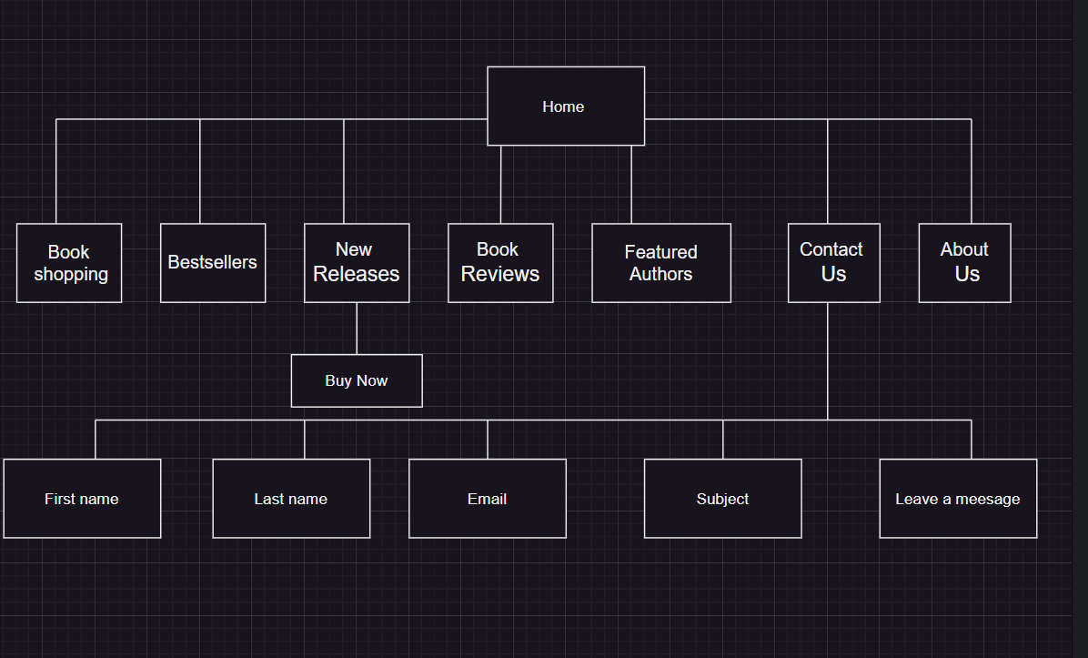

**f-**

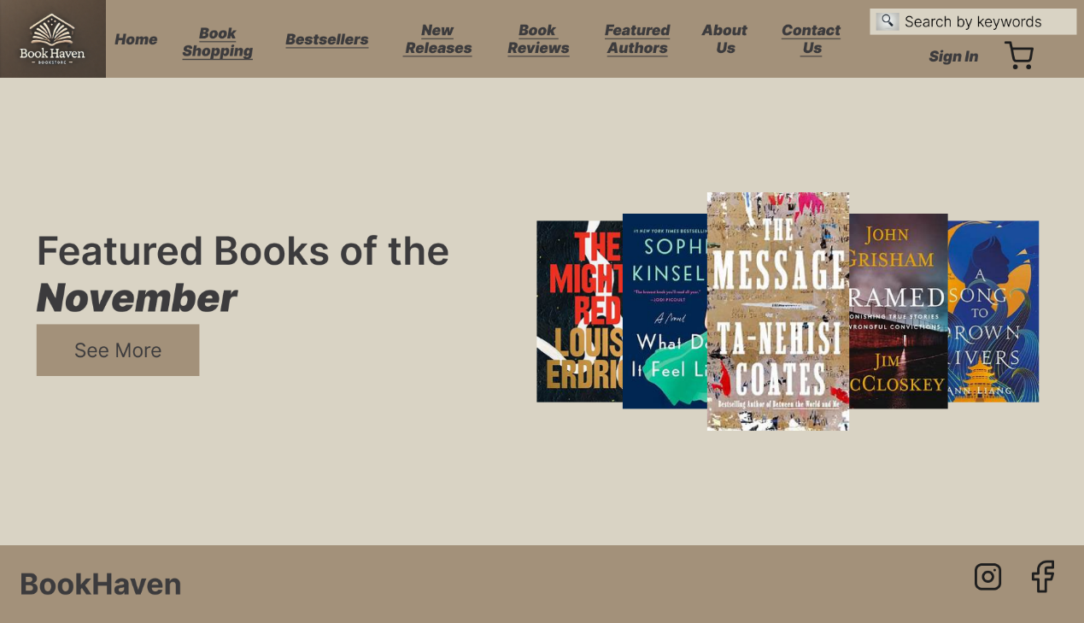

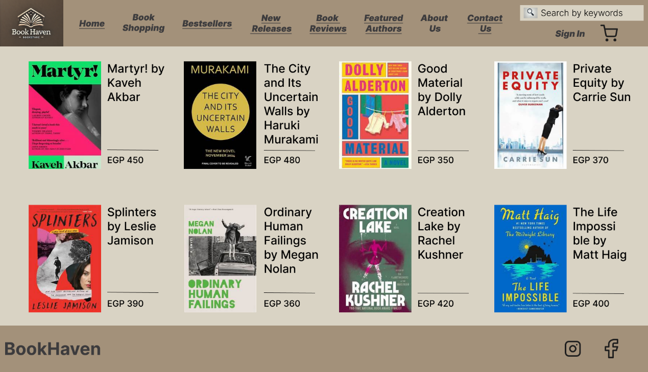

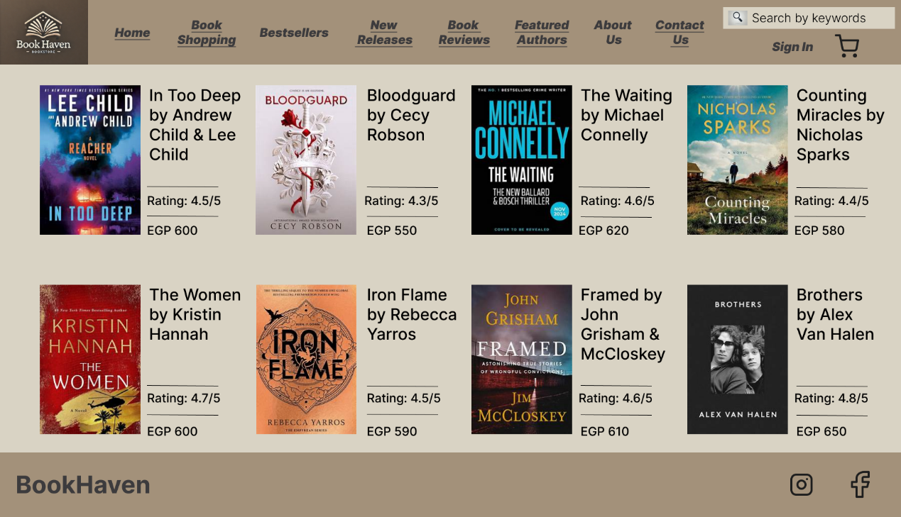

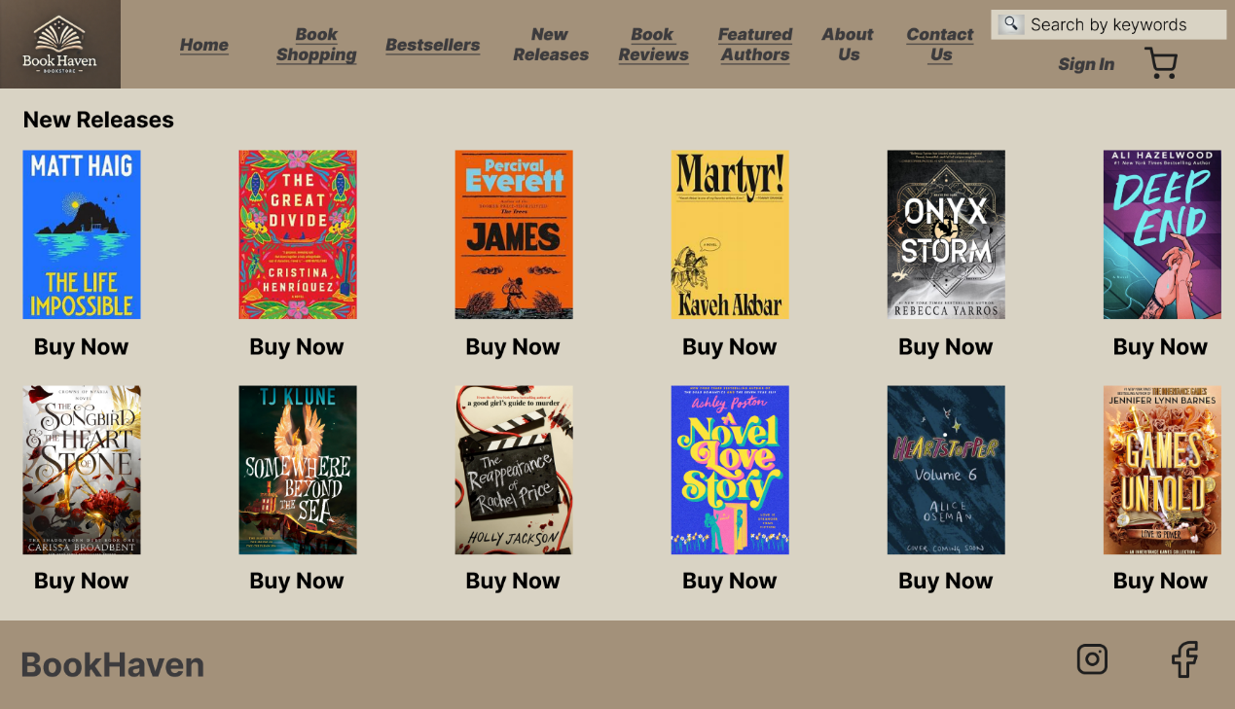

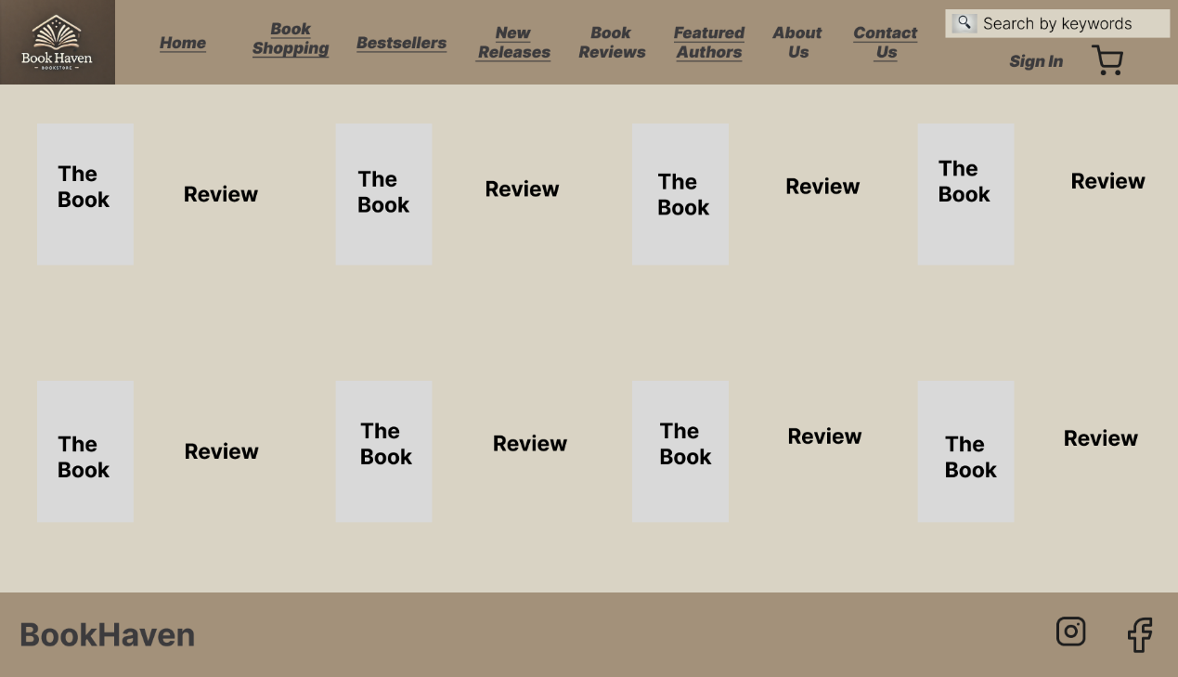

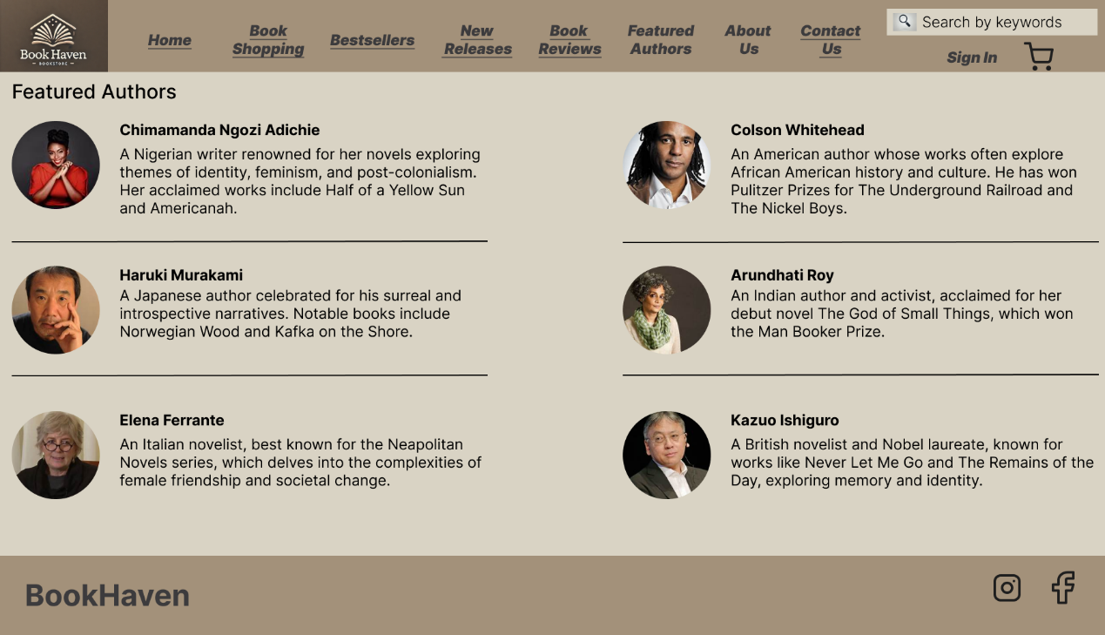

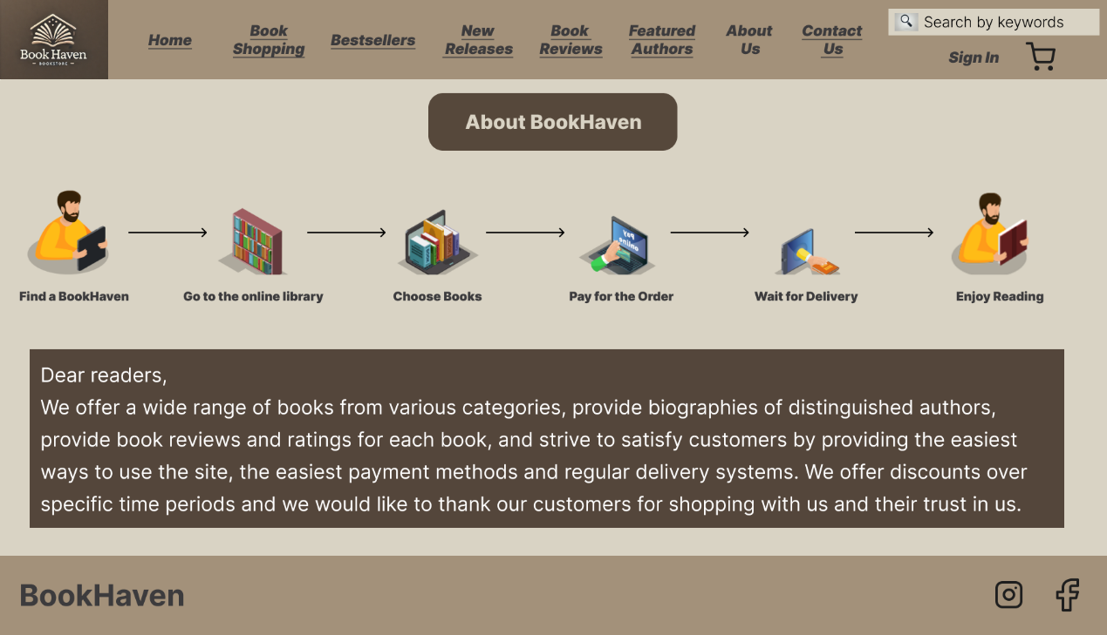

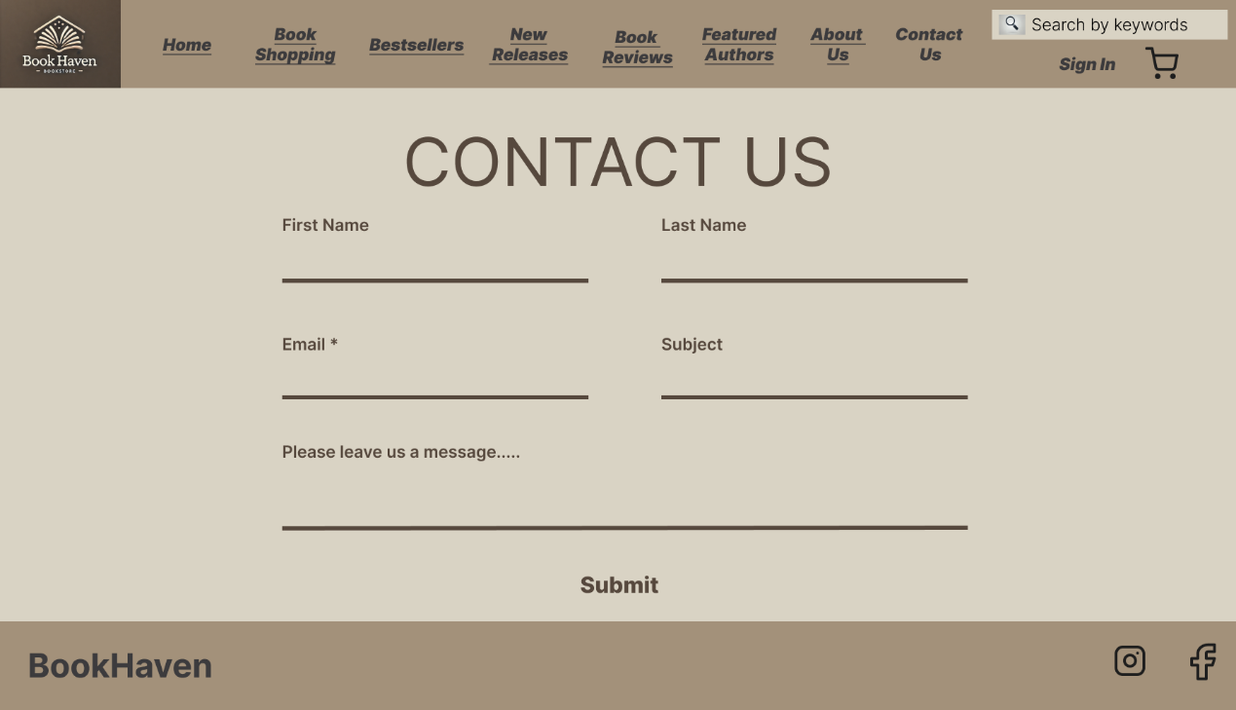

**2.3.3. Part 2: website design**

**[A]**

**Home page:** The design of this page achieves simplicity, structure, and clarity through principles like Prägnanz, Closure, Symmetry and Order, Figure/Ground and Proximity, and don't achieve Continuation, Common Fate, Parallelism, and Similarity.

**Book Shopping:** The design of this page achieves simplicity, clarity, and organization through principles like Prägnanz, Closure, Symmetry and Order, Figure/Ground, Proximity and Past Experience. It doesn't achieve Continuation, Common Fate, Parallelism, and Similarity could enhance flow, user engagement, and cohesion among elements.

**Bestsellers:** The design of this page achieves simplicity, clarity, and organization by effectively applying principles like Prägnanz, Closure, Symmetry and Order, Figure/Ground, Proximity, Similarity and Past Experience. Areas for improvement include Continuation, Common Fate, and Parallelism.

**New Releases:** The design of this page achieves simplicity, clarity, and organization through principles like Prägnanz, Closure, Symmetry and Order, Figure/Ground, Uniform Connectedness, Common Region, Proximity, Similarity, and Past Experience. It doesn't achieve Continuation, Common Fate, and Parallelism could enhance visual flow, interaction, and consistency.

**Book Reviews:** The design of this page achieves simplicity, clarity, and organization through principles like Prägnanz, Closure, Symmetry and Order, Figure/Ground, Uniform Connectedness, Common Region, Proximity, Similarity, and Past Experience. It doesn't achieve Continuation, Common Fate, and Parallelism could enhance the visual flow, engagement, and consistency of the layout.

**Featured Authors:** The design of this page achieves simplicity, organization, and clarity through principles like Prägnanz, Closure, Symmetry and Order, Figure/Ground, Uniform Connectedness, Common Region, Proximity, Similarity, and Past Experience. It doesn't achieve Continuation, Common Fate, and Parallelism could enhance the visual flow, interactivity, and structural consistency.

**About Us:** The design of this page successfully achieves simplicity, clarity, flow, and organization through principles like Prägnanz, Closure, Symmetry and Order, Figure/Ground, Uniform Connectedness, Common Region, Proximity, Continuation, and Past Experience. It doesn't achieve Common Fate, Parallelism, and Similarity could enhance interactivity, alignment consistency, and visual cohesion.

**Contact Us:** The design of this page achieves simplicity, clarity, and organization through principles like Prägnanz, Closure, Symmetry and Order, Figure/Ground, Uniform Connectedness, Common Region, Proximity, Similarity, and Past Experience. It doesn't achieve Continuation, Common Fate, and Parallelism could improve visual flow, engagement, and alignment consistency.

**[B]**

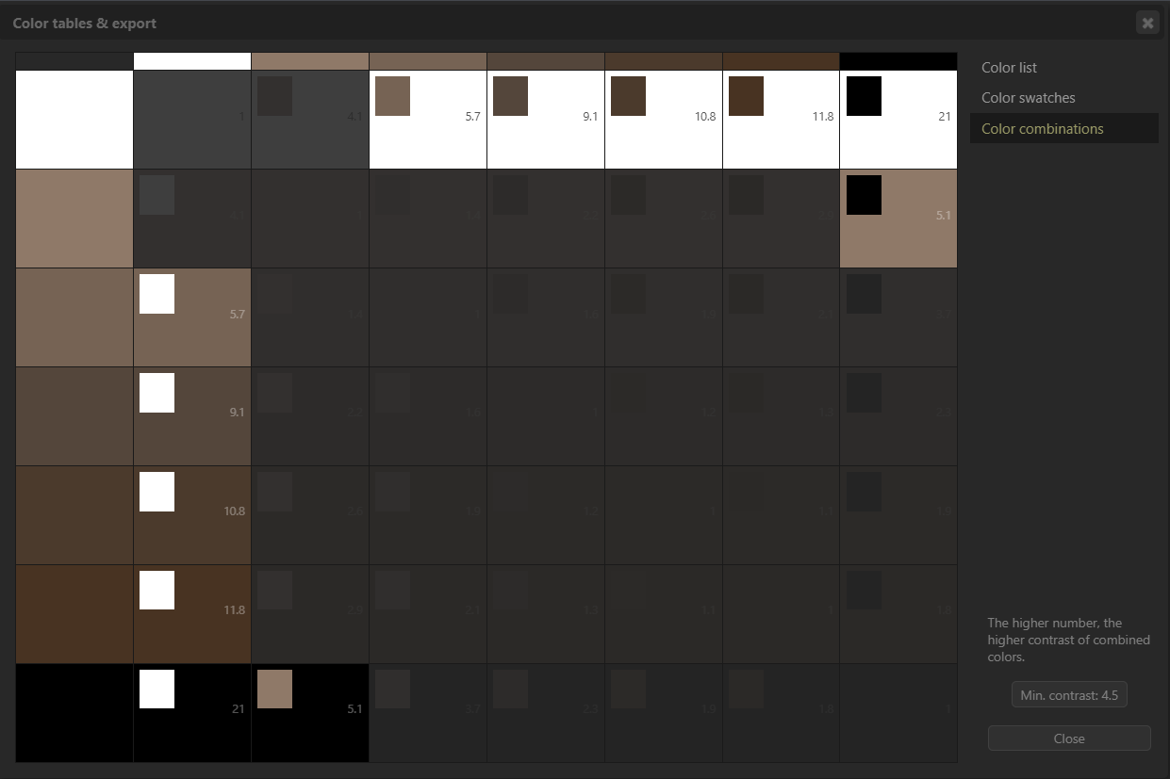

**The code of Homepage:**

<!DOCTYPE html>

<html lang="en">

<head>

    <meta charset="UTF-8">

    <meta name="viewport" content="width=device-width, initial-scale=1.0">

    <title>BookHaven</title>

    <link rel="stylesheet" href="styles.css">

</head>

<body>

    <header>

        <div class="logo">

            <img src="bookhaven_logo.png" alt="BookHaven Logo">

        </div>

        <nav>

            <ul>

                <li><a href="#">Home</a></li>

                <li><a href="#">Book Shopping</a></li>

                <li><a href="#">Bestsellers</a></li>

                <li><a href="#">New Releases</a></li>

                <li><a href="#">Book Reviews</a></li>

                <li><a href="#">Featured Authors</a></li>

                <li><a href="#">About Us</a></li>

                <li><a href="#">Contact Us</a></li>

            </ul>

        </nav>

    </header>

    <main>

        <section class="featured-books">

            <h2>Featured Books of the <span>November</span></h2>

            </div>

        </section>

    </main>

</body>

</html>

**The code of Book shopping page:**

<!DOCTYPE html>

<html lang="en">

<head>

    <meta charset="UTF-8">

    <meta name="viewport" content="width=device-width, initial-scale=1.0">

    <title>BookHaven - Book Shopping</title>

    <link rel="stylesheet" href="styles.css">

</head>

<body>

    <header>

        <div class="logo">

            <img src="bookhaven_logo.png" alt="BookHaven Logo">

        </div>

        <nav>

            <ul>

                <li><a href="#">Home</a></li>

                <li><a href="#">Book Shopping</a></li>

                <li><a href="#">Bestsellers</a></li>

                <li><a href="#">New Releases</a></li>

                <li><a href="#">Book Reviews</a></li>

                <li><a href="#">Featured Authors</a></li>

                <li><a href="#">About Us</a></li>

                <li><a href="#">Contact Us</a></li>

            </ul>

        </nav>

    </header>

    <main>

        <section class="book-shopping">

            <h2>Featured Books of the Month</h2>

            <div class="book-grid">

                <div class="book-item">

                    <img src="martyr.jpg" alt="Martyr! by Kaveh Akbar">

                    <p>Martyr! by Kaveh Akbar</p>

                    <p>EGP 450</p>

                </div>

                <div class="book-item">

                    <img src="murakami.jpg" alt="The City and Its Uncertain Walls by Haruki Murakami">

                    <p>The City and Its Uncertain Walls by Haruki Murakami</p>

                    <p>EGP 480</p>

                </div>

                <div class="book-item">

                    <img src="dolly_alderton.jpg" alt="Good Material by Dolly Alderton">

                    <p>Good Material by Dolly Alderton</p>

                    <p>EGP 350</p>

                </div>

                <div class="book-item">

                    <img src="private_equity.jpg" alt="Private Equity by Carrie Sun">

                    <p>Private Equity by Carrie Sun</p>

                    <p>EGP 370</p>

                </div>

                <div class="book-item">

                    <img src="splinters.jpg" alt="Splinters by Leslie Jamison">

                    <p>Splinters by Leslie Jamison</p>

                    <p>EGP 390</p>

                </div>

                <div class="book-item">

                    <img src="ordinary_human_failings.jpg" alt="Ordinary Human Failings by Megan Nolan">

                    <p>Ordinary Human Failings by Megan Nolan</p>

                    <p>EGP 360</p>

                </div>

                <div class="book-item">

                    <img src="creation_lake.jpg" alt="Creation Lake by Rachel Kushner">

                    <p>Creation Lake by Rachel Kushner</p>

                    <p>EGP 420</p>

                </div>

                <div class="book-item">

                    <img src="life_impossible.jpg" alt="The Life Impossible by Matt Haig">

                    <p>The Life Impossible by Matt Haig</p>

                    <p>EGP 400</p>

                </div>

            </div>

        </section>

    </main>

    <footer>

        <div class="footer-logo">

            <h3>BookHaven</h3>

        </div>

    </footer>

</body>

</html>

**The code of Bestsellers page:**

<!DOCTYPE html>

<html lang="en">

<head>

    <meta charset="UTF-8">

    <meta name="viewport" content="width=device-width, initial-scale=1.0">

    <title>BookHaven - Bestsellers</title>

    <link rel="stylesheet" href="styles.css">

</head>

<body>

    <header>

        <div class="logo">

            <img src="bookhaven_logo.png" alt="BookHaven Logo">

        </div>

        <nav>

            <ul>

                <li><a href="#">Home</a></li>

                <li><a href="#">Book Shopping</a></li>

                <li><a href="#">Bestsellers</a></li>

                <li><a href="#">New Releases</a></li>

                <li><a href="#">Book Reviews</a></li>

                <li><a href="#">Featured Authors</a></li>

                <li><a href="#">About Us</a></li>

                <li><a href="#">Contact Us</a></li>

            </ul>

        </nav>

    </header>

    <main>

        <section class="bestsellers">

            <h2>Bestsellers</h2>

            <div class="book-grid">

                <div class="book-item">

                    <img src="into_deep.jpg" alt="In Too Deep by Andrew Child & Lee Child">

                    <p>In Too Deep by Andrew Child & Lee Child</p>

                    <p>Rating: 4.5/5</p>

                    <p>EGP 600</p>

                </div>

                <div class="book-item">

                    <img src="bloodguard.jpg" alt="Bloodguard by Cecy Robson">

                    <p>Bloodguard by Cecy Robson</p>

                    <p>Rating: 4.3/5</p>

                    <p>EGP 550</p>

                </div>

                <div class="book-item">

                    <img src="waiting.jpg" alt="The Waiting by Michael Connelly">

                    <p>The Waiting by Michael Connelly</p>

                    <p>Rating: 4.6/5</p>

                    <p>EGP 620</p>

                </div>

                <div class="book-item">

                    <img src="counting_miracles.jpg" alt="Counting Miracles by Nicholas Sparks">

                    <p>Counting Miracles by Nicholas Sparks</p>

                    <p>Rating: 4.4/5</p>

                    <p>EGP 580</p>

                </div>

                <div class="book-item">

                    <img src="the_women.jpg" alt="The Women by Kristin Hannah">

                    <p>The Women by Kristin Hannah</p>

                    <p>Rating: 4.7/5</p>

                    <p>EGP 600</p>

                </div>

                <div class="book-item">

                    <img src="iron_flame.jpg" alt="Iron Flame by Rebecca Yarros">

                    <p>Iron Flame by Rebecca Yarros</p>

                    <p>Rating: 4.5/5</p>

                    <p>EGP 590</p>

                </div>

                <div class="book-item">

                    <img src="framed.jpg" alt="Framed by John Grisham & McCloskey">

                    <p>Framed by John Grisham & McCloskey</p>

                    <p>Rating: 4.6/5</p>

                    <p>EGP 610</p>

                </div>

                <div class="book-item">

                    <img src="brothers.jpg" alt="Brothers by Alex Van Halen">

                    <p>Brothers by Alex Van Halen</p>

                    <p>Rating: 4.8/5</p>

                    <p>EGP 650</p>

                </div>

            </div>

        </section>

    </main>

    <footer>

        <div class="footer-logo">

            <h3>BookHaven</h3>

        </div>

    </footer>

</body>

</html>

The code of New Releases page:

<!DOCTYPE html>

<html lang="en">

<head>

    <meta charset="UTF-8">

    <meta name="viewport" content="width=device-width, initial-scale=1.0">

    <title>BookHaven - New Releases</title>

    <link rel="stylesheet" href="styles.css">

</head>

<body>

    <header>

        <div class="logo">

            <img src="bookhaven_logo.png" alt="BookHaven Logo">

        </div>

        <nav>

            <ul>

                <li><a href="#">Home</a></li>

                <li><a href="#">Book Shopping</a></li>

                <li><a href="#">Bestsellers</a></li>

                <li><a href="#">New Releases</a></li>

                <li><a href="#">Book Reviews</a></li>

                <li><a href="#">Featured Authors</a></li>

                <li><a href="#">About Us</a></li>

                <li><a href="#">Contact Us</a></li>

            </ul>

        </nav>

    </header>

    <main>

        <section class="new-releases">

            <h2>New Releases</h2>

            <div class="book-grid">

                <div class="book-item">

                    <img src="life_impossible.jpg" alt="The Life Impossible by Matt Haig">

                    <p>The Life Impossible by Matt Haig</p>

                    <button class="buy-now">Buy Now</button>

                </div>

                <div class="book-item">

                    <img src="great_divide.jpg" alt="The Great Divide by Cristina Henríquez">

                    <p>The Great Divide by Cristina Henríquez</p>

                    <button class="buy-now">Buy Now</button>

                </div>

                <div class="book-item">

                    <img src="james.jpg" alt="James by Percival Everett">

                    <p>James by Percival Everett</p>

                    <button class="buy-now">Buy Now</button>

                </div>

                <div class="book-item">

                    <img src="martyr.jpg" alt="Martyr! by Kaveh Akbar">

                    <p>Martyr! by Kaveh Akbar</p>

                    <button class="buy-now">Buy Now</button>

                </div>

                <div class="book-item">

                    <img src="onyx_storm.jpg" alt="Onyx Storm by Rebecca Yarros">

                    <p>Onyx Storm by Rebecca Yarros</p>

                    <button class="buy-now">Buy Now</button>

                </div>

                <div class="book-item">

                    <img src="deep_end.jpg" alt="Deep End by Ali Hazelwood">

                    <p>Deep End by Ali Hazelwood</p>

                    <button class="buy-now">Buy Now</button>

                </div>

                <div class="book-item">

                    <img src="songbird.jpg" alt="The Songbird & the Heart Stone by Carissa Broadbent">

                    <p>The Songbird & the Heart Stone by Carissa Broadbent</p>

                    <button class="buy-now">Buy Now</button>

                </div>

                <div class="book-item">

                    <img src="somewhere_sea.jpg" alt="Somewhere Beyond the Sea by TJ Klune">

                    <p>Somewhere Beyond the Sea by TJ Klune</p>

                    <button class="buy-now">Buy Now</button>

                </div>

                <div class="book-item">

                    <img src="reappearance_rachel.jpg" alt="The Reappearance of Rachel Price by Holly Jackson">

                    <p>The Reappearance of Rachel Price by Holly Jackson</p>

                    <button class="buy-now">Buy Now</button>

                </div>

                <div class="book-item">

                    <img src="novel_love_story.jpg" alt="A Novel Love Story by Ashley Poston">

                    <p>A Novel Love Story by Ashley Poston</p>

                    <button class="buy-now">Buy Now</button>

                </div>

                <div class="book-item">

                    <img src="heartstopper_vol6.jpg" alt="Heartstopper Volume 6 by Alice Oseman">

                    <p>Heartstopper Volume 6 by Alice Oseman</p>

                    <button class="buy-now">Buy Now</button>

                </div>

                <div class="book-item">

                    <img src="games_untold.jpg" alt="Games Untold by Jennifer Lynn Barnes">

                    <p>Games Untold by Jennifer Lynn Barnes</p>

                    <button class="buy-now">Buy Now</button>

                </div>

            </div>

        </section>

    </main>

    <footer>

        <div class="footer-logo">

            <h3>BookHaven</h3>

        </div>

    </footer>

</body>

</html>

**The code of Book Reviews page:**

<!DOCTYPE html>

<html lang="en">

<head>

    <meta charset="UTF-8">

    <meta name="viewport" content="width=device-width, initial-scale=1.0">

    <title>BookHaven - Book Reviews</title>

    <link rel="stylesheet" href="styles.css">

</head>

<body>

    <header>

        <div class="logo">

            <img src="bookhaven_logo.png" alt="BookHaven Logo">

        </div>

        <nav>

            <ul>

                <li><a href="#">Home</a></li>

                <li><a href="#">Book Shopping</a></li>

                <li><a href="#">Bestsellers</a></li>

                <li><a href="#">New Releases</a></li>

                <li><a href="#">Book Reviews</a></li>

                <li><a href="#">Featured Authors</a></li>

                <li><a href="#">About Us</a></li>

                <li><a href="#">Contact Us</a></li>

            </ul>

        </nav>

    </header>

    <main>

        <section class="book-reviews">

            <h2>Book Reviews</h2>

            <div class="review-grid">

                <div class="review-item">

                    <div class="book-cover">The Book</div>

                    <div class="review-text">Review</div>

                </div>

                <div class="review-item">

                    <div class="book-cover">The Book</div>

                    <div class="review-text">Review</div>

                </div>

                <div class="review-item">

                    <div class="book-cover">The Book</div>

                    <div class="review-text">Review</div>

                </div>

                <div class="review-item">

                    <div class="book-cover">The Book</div>

                    <div class="review-text">Review</div>

                </div>

                <div class="review-item">

                    <div class="book-cover">The Book</div>

                    <div class="review-text">Review</div>

                </div>

                <div class="review-item">

                    <div class="book-cover">The Book</div>

                    <div class="review-text">Review</div>

                </div>

                <div class="review-item">

                    <div class="book-cover">The Book</div>

                    <div class="review-text">Review</div>

                </div>

                <div class="review-item">

                    <div class="book-cover">The Book</div>

                    <div class="review-text">Review</div>

                </div>

            </div>

        </section>

    </main>

    <footer>

        <div class="footer-logo">

            <h3>BookHaven</h3>

        </div>

    </footer>

</body>

</html>

**The code of Featured Authors page:**

<!DOCTYPE html>

<html lang="en">

<head>

    <meta charset="UTF-8">

    <meta name="viewport" content="width=device-width, initial-scale=1.0">

    <title>BookHaven - Featured Authors</title>

    <link rel="stylesheet" href="styles.css">

</head>

<body>

    <header>

        <div class="logo">

            <img src="bookhaven_logo.png" alt="BookHaven Logo">

        </div>

        <nav>

            <ul>

                <li><a href="#">Home</a></li>

                <li><a href="#">Book Shopping</a></li>

                <li><a href="#">Bestsellers</a></li>

                <li><a href="#">New Releases</a></li>

                <li><a href="#">Book Reviews</a></li>

                <li><a href="#">Featured Authors</a></li>

                <li><a href="#">About Us</a></li>

                <li><a href="#">Contact Us</a></li>

            </ul>

        </nav>

    </header>

    <main>

        <section class="featured-authors">

            <h2>Featured Authors</h2>

            <div class="author-grid">

                <div class="author-item">

                    <img src="chimamanda.jpg" alt="Chimamanda Ngozi Adichie">

                    <h3>Chimamanda Ngozi Adichie</h3>

                    <p>A Nigerian writer renowned for her novels exploring themes of identity, feminism, and post-colonialism. Her acclaimed works include <em>Half of a Yellow Sun</em> and <em>Americanah</em>.</p>

                </div>

                <div class="author-item">

                    <img src="colson_whitehead.jpg" alt="Colson Whitehead">

                    <h3>Colson Whitehead</h3>

                    <p>An American author whose works often explore African American history and culture. He has won Pulitzer Prizes for <em>The Underground Railroad</em> and <em>The Nickel Boys</em>.</p>

                </div>

                <div class="author-item">

                    <img src="haruki_murakami.jpg" alt="Haruki Murakami">

                    <h3>Haruki Murakami</h3>

                    <p>A Japanese author celebrated for his surreal and introspective narratives. Notable books include <em>Norwegian Wood</em> and <em>Kafka on the Shore</em>.</p>

                </div>

                <div class="author-item">

                    <img src="arundhati_roy.jpg" alt="Arundhati Roy">

                    <h3>Arundhati Roy</h3>

                    <p>An Indian author and activist, acclaimed for her debut novel <em>The God of Small Things</em>, which won the Man Booker Prize.</p>

                </div>

                <div class="author-item">

                    <img src="elena_ferrante.jpg" alt="Elena Ferrante">

                    <h3>Elena Ferrante</h3>

                    <p>An Italian novelist, best known for the <em>Neapolitan Novels</em> series, which delves into the complexities of female friendship and societal change.</p>

                </div>

                <div class="author-item">

                    <img src="kazuo_ishiguro.jpg" alt="Kazuo Ishiguro">

                    <h3>Kazuo Ishiguro</h3>

                    <p>A British novelist and Nobel laureate, known for works like <em>Never Let Me Go</em> and <em>The Remains of the Day</em>, exploring memory and identity.</p>

                </div>

            </div>

        </section>

    </main>

    <footer>

        <div class="footer-logo">

            <h3>BookHaven</h3>

        </div>

    </footer>

</body>

</html>

**The code of About Us page:**

<!DOCTYPE html>

<html lang="en">

<head>

    <meta charset="UTF-8">

    <meta name="viewport" content="width=device-width, initial-scale=1.0">

    <title>About BookHaven</title>

    <link rel="stylesheet" href="styles.css">

</head>

<body>

    <header>

        <nav>

            <img src="logo.png" alt="BookHaven Logo" id="logo">

            <ul>

                <li><a href="#">Home</a></li>

                <li><a href="#">Book Shopping</a></li>

                <li><a href="#">Bestsellers</a></li>

                <li><a href="#">New Releases</a></li>

                <li><a href="#">Book Reviews</a></li>

                <li><a href="#">Featured Authors</a></li>

                <li><a href="#">About Us</a></li>

                <li><a href="#">Contact Us</a></li>

            </ul>

        </nav>

    </header>

    <section class="about-section">

        <h1>About BookHaven</h1>

        <div class="process-flow">

            <div class="step">

                <img src="find-bookhaven.png" alt="Find a BookHaven">

                <p>Find a BookHaven</p>

            </div>

            <div class="step">

                <img src="online-library.png" alt="Go to the online library">

                <p>Go to the online library</p>

            </div>

            <div class="step">

                <img src="choose-books.png" alt="Choose Books">

                <p>Choose Books</p>

            </div>

            <div class="step">

                <img src="pay-order.png" alt="Pay for the Order">

                <p>Pay for the Order</p>

            </div>

            <div class="step">

                <img src="wait-delivery.png" alt="Wait for Delivery">

                <p>Wait for Delivery</p>

            </div>

            <div class="step">

                <img src="enjoy-reading.png" alt="Enjoy Reading">

                <p>Enjoy Reading</p>

            </div>

        </div>

        <div class="about-text">

            <p>Dear readers,</p>

            <p>We offer a wide range of books from various categories, provide biographies of distinguished authors, provide book reviews and ratings for each book, and strive to satisfy customers by providing the easiest ways to use the site, the easiest payment methods and regular delivery systems. We offer discounts over specific time periods and we would like to thank our customers for shopping with us and their trust in us.</p>

        </div>

    </section>

    <footer>

        <p>BookHaven</p>

    </footer>

</body>

</html>

**The code of Contact US page:**

<!DOCTYPE html>

<html lang="en">

<head>

    <meta charset="UTF-8">

    <meta name="viewport" content="width=device-width, initial-scale=1.0">

    <title>Contact Us - BookHaven</title>

    <link rel="stylesheet" href="styles.css">

</head>

<body>

    <header>

        <nav>

            <img src="logo.png" alt="BookHaven Logo" id="logo">

            <ul>

                <li><a href="#">Home</a></li>

                <li><a href="#">Book Shopping</a></li>

                <li><a href="#">Bestsellers</a></li>

                <li><a href="#">New Releases</a></li>

                <li><a href="#">Book Reviews</a></li>

                <li><a href="#">Featured Authors</a></li>

                <li><a href="#">About Us</a></li>

                <li><a href="#">Contact Us</a></li>

            </ul>

        </nav>

    </header>

    <section class="contact-section">

        <h1>Contact Us</h1>

        <form action="submit_form.php" method="post">

            <div class="form-row">

                <div class="form-group">

                    <label for="firstName">First Name</label>

                </div>

                <div class="form-group">

                    <label for="lastName">Last Name</label>

                </div>

            </div>

            <div class="form-row">

                <div class="form-group">

                    <label for="email">Email *</label>

                </div>

                <div class="form-group">

                    <label for="subject">Subject</label>

                </div>

            </div>

            <div class="form-group">

                <label for="message">Please leave us a message...</label>

            </div>

        </form>

    </section>

    <footer>

        <p>BookHaven</p>

    </footer>

</body>

</html>

**References:**

**[1]** Tim O'Reilly. “What Is Web 2.0:Design Patterns and Business Models for the Next Generation of Software [EB/OL],http://www.oreillynet.com/pub/a/oreilly/tim/news/ 2005/09/30/what-is-web-20.html

**[2]** T. O’Reilly, What is Web 2.0? – Design Patterns and Business Models for the Next Generation of Software, <http://oreilly.com/web2/archive/what-is-web-20.html,2005>.

**[3]** Singh, H. (2023). The New Era in Education: Web 3.0. TAM METİN BİLDİRİ KİTABI, 78.

**[4]** Patil, H. J., & Surwade, Y. P. (2018). Web technologies from web 2.0 to web 4.0. International journal for science and advance research in technology, 4(4), 810-814.

**[5]** Gholami, B., & Safavi, R. (2010, January). Harnessing collective intelligence: Wiki and social network from end-user perspective. In 2010 International Conference on e-Education, e-Business, e-Management and e-Learning (pp. 242-246). IEEE.

**[6]** Shilina, S. (2023). The future of social networking: Decentralization for user empowerment, privacy, and freedom from censorship.

**[7]** Chee Hong, K., Shibghatullah, A. S., Chee Ling, T., Sarsam, S., & Ahmad Qazi, S. (2023). Bridging web 4.0 and education 4.0 for next generation user training in ERP ADOPTION. Journal of Theoretical and Applied Information Technology, 101(22).